**DBMS Assessment**

The city table :-

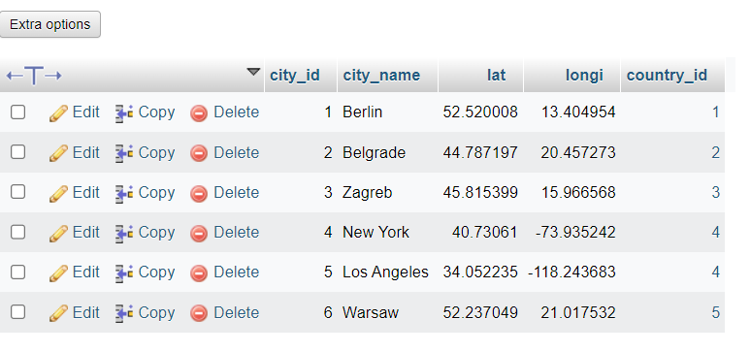

The customer table :-

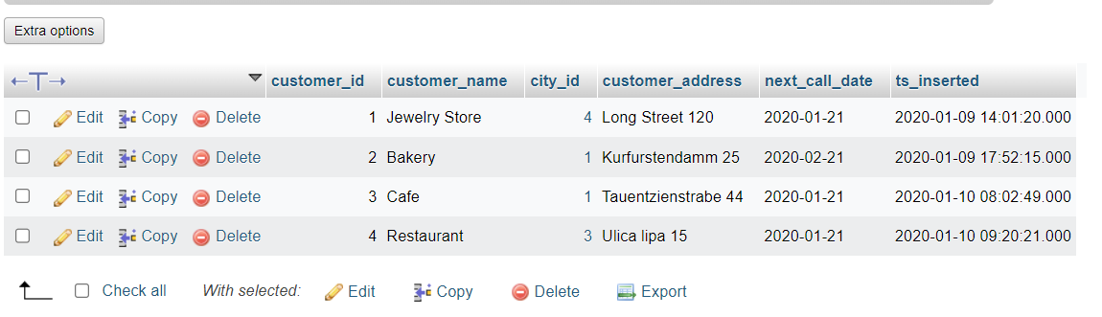

The country table :-

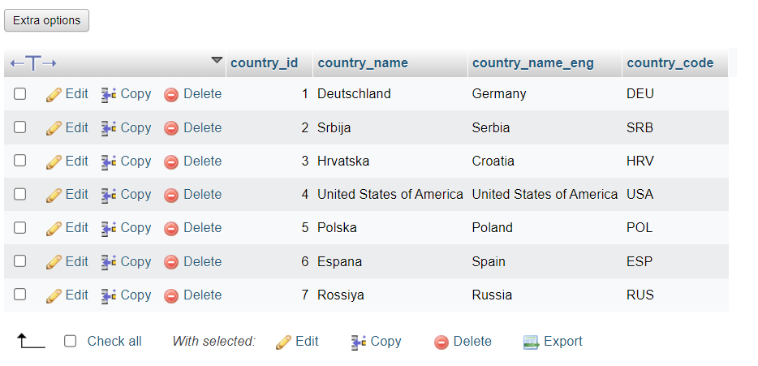

**Task : 1** (join multiple tables using left join)

List all Countries and customers related to these countries.

For each country displaying its name in English, the name of the city customer is located in as well as the name of the customer.

Return even countries without related cities and customers.

ANS-

[SELECT](http://localhost/phpmyadmin/url.php?url=https://dev.mysql.com/doc/refman/8.0/en/select.html) country_table.country_name_eng, city_table.city_name, customer_table.customer_name FROM customer_table [LEFT](http://localhost/phpmyadmin/url.php?url=https://dev.mysql.com/doc/refman/8.0/en/string-functions.html%23function_left) JOIN city_table ON customer_table.city_id=city_table.city_id [LEFT](http://localhost/phpmyadmin/url.php?url=https://dev.mysql.com/doc/refman/8.0/en/string-functions.html%23function_left) JOIN country_table ON city_table.country_id=country_table.country_id;

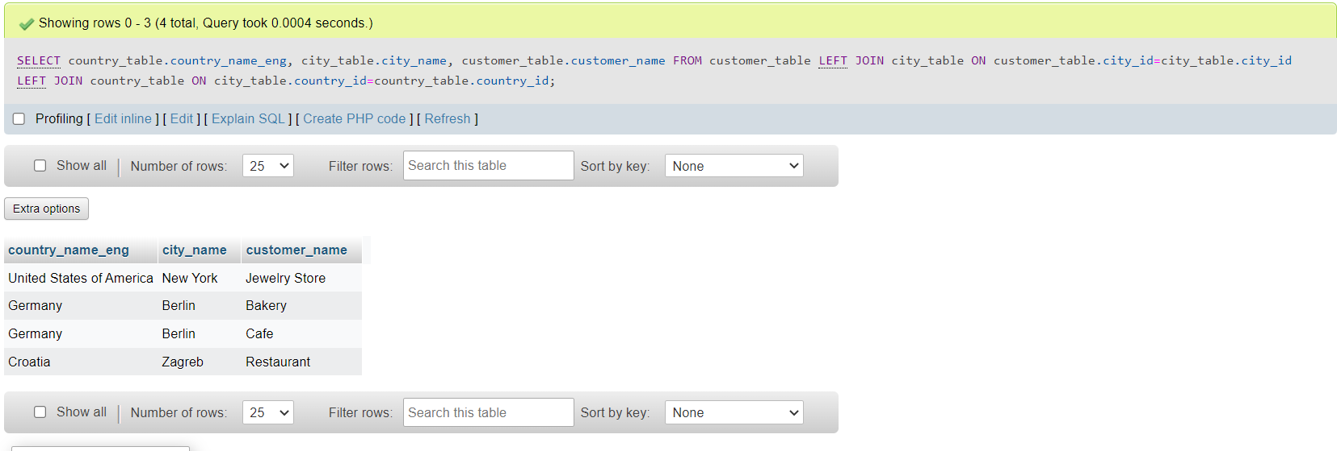

**Task : 2** (join multiple tables using both left and inner join)

Return the list of all countries that have pairs(exclude countries which are not referenced by any city). For such pairs return all customers.

Return even pairs of not having a single customer

[SELECT](http://localhost/phpmyadmin/url.php?url=https://dev.mysql.com/doc/refman/8.0/en/select.html) country_table.country_name_eng, city_table.city_name, customer_table.customer_name FROM country_table INNER JOIN city_table ON city_table.country_id = country_table.country_id [LEFT](http://localhost/phpmyadmin/url.php?url=https://dev.mysql.com/doc/refman/8.0/en/string-functions.html%23function_left) JOIN customer_table ON customer_table.city_id = city_table.city_id;

